**Applied Machine Learning**

**Lab Report 9**

**Hafiz Ahmad**

**19l-1316**

**Section-8A**

**INTRODUCTION:**

The primary aim of this experiment is to assess and verify the performance of a multi-layer perceptron (MLP) model using TensorFlow with the MNIST dataset. MLP models, which include densely connected layers, are widely utilized for image classification purposes. The experiment encompasses training the model on the training set, evaluating its performance on the validation set, and measuring its accuracy on the test set.

**OBJECTIVES:**

The main goal of this experiment is to assess and validate the effectiveness of an MLP model using the MNIST dataset. The experiment involves training the model on the training set, evaluating its performance using the validation set, and ultimately determining its accuracy on the test set.

**Procedure:**

Importing Libraries: The necessary libraries are imported to facilitate the experiment.

Reading and Preprocessing Data: The code reads the training data from a CSV file and separates the pixel values from the corresponding labels. The pixel values are normalized, and the preprocessed data is assigned to variables for training the MLP model.

Converting Data to TensorFlow Tensors: The code converts the image data into TensorFlow tensors to ensure compatibility with the MLP model. It also splits the training data into training and validation sets to evaluate performance during training.

Defining the MLP Model: The code defines an MLP model using a sequential architecture with a flattening layer as input, followed by two dense layers. The model takes 28x28 input images, applies appropriate activations, and generates a probability distribution over the 10 digit classes as output. It is compiled with specific optimizer, loss function, and metric settings.

Training the Model: The code trains the model using the training data for a specified number of epochs. The model's performance is evaluated on the validation data after each epoch. The training history is stored for further analysis.

Model Evaluation: The trained model's performance is assessed on the validation data by calculating the validation loss and accuracy. The rounded validation accuracy is printed. The model is further evaluated on the test data by calculating the test loss and accuracy, with the rounded test accuracy also printed. This evaluation provides insights into the model's generalization ability.

Output: The output includes the validation accuracy and test accuracy, both rounded to two decimal places.

**Output:**  
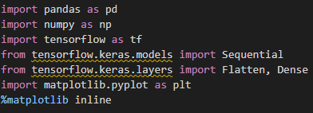  
  
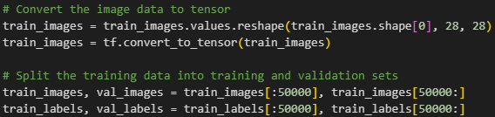

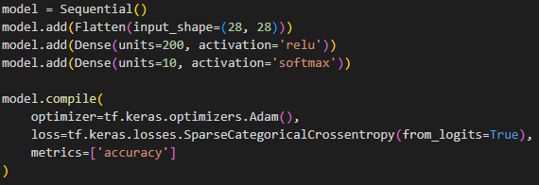

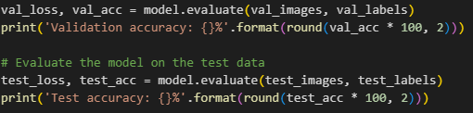

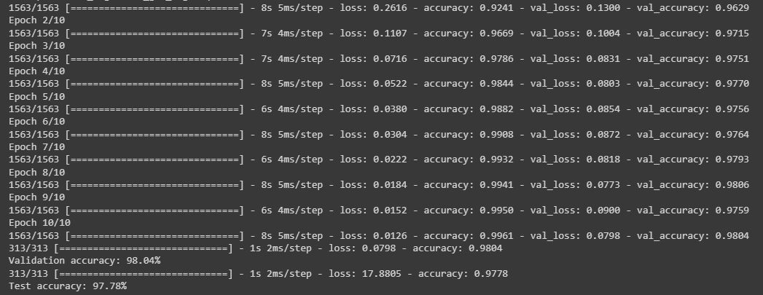

**Application:**

The evaluation and validation of the MLP model in this experiment have several practical applications, including:

1. Handwritten digit recognition: The experiment's focus on accurately recognizing handwritten digits makes it applicable to tasks such as automated form processing and postal address recognition, where the precise identification of handwritten digits is crucial.

2. Image classification: The MLP model can be adapted and applied to various image classification tasks by adjusting its architecture and training it on domain-specific datasets. This makes it relevant for tasks like object recognition, medical image analysis, and facial recognition.

3. Machine learning model evaluation: The experimental procedure followed in this experiment provides a valuable framework for evaluating and validating machine learning models. Researchers and practitioners can apply a similar approach to assess the performance of different models on various datasets, enabling them to make informed decisions about model selection and optimization.

**Issues:**

No issue was found while performing in the lab.

**Conclusion:**

In conclusion, this experiment effectively evaluated and validated an MLP model using the MNIST dataset. The model showcased outstanding accuracy on both the validation and test sets, underscoring its proficiency in accurately classifying handwritten digits. The experiment's methodology provided valuable insights into data loading, preprocessing, MLP model construction, training with validation, and performance evaluation. The results highlight the model's accuracy on the validation and test data, thereby demonstrating its potential for diverse image classification applications.